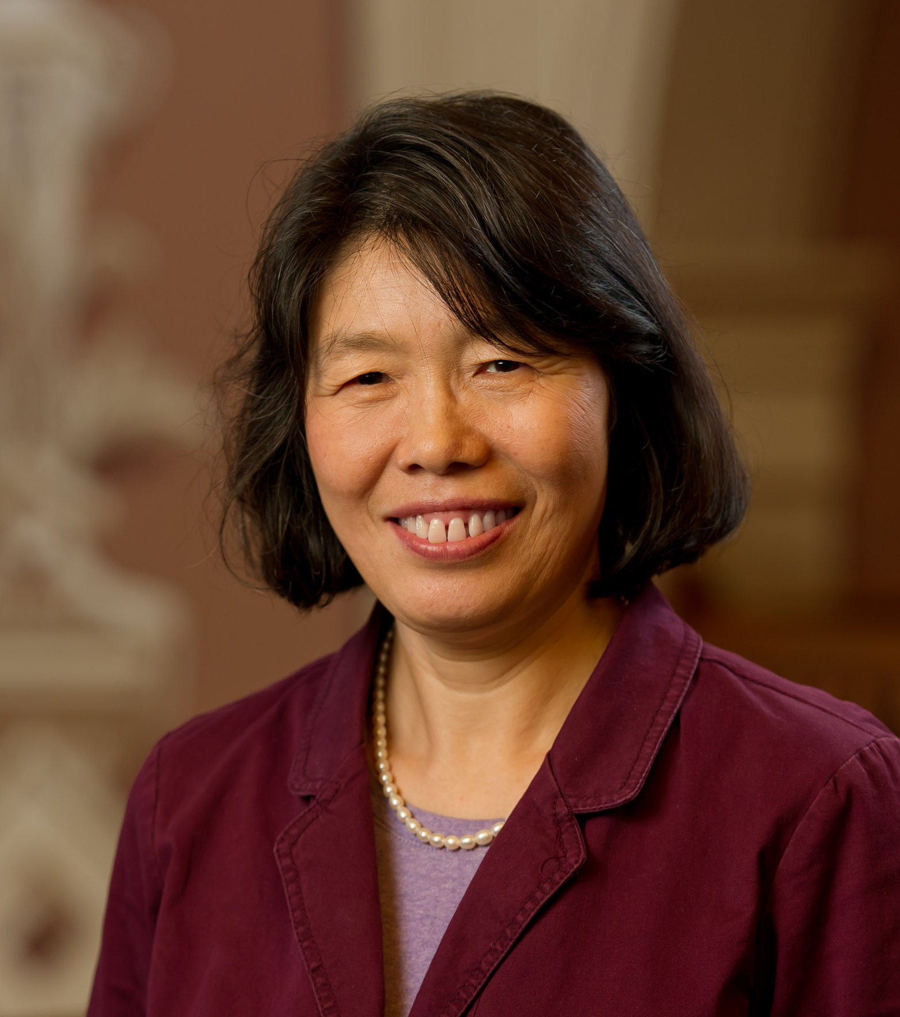

题目：A Cross-Layer Perspective for Energy Efficient Processing --- From beyond-CMOS devices to deep learning
报告人：X. Sharon Hu, University of Notre Dame, USA
时间：11月13日，上午10:00
地点：东主楼 10-103
场次：第35场

Abstract：
As Moore’s Law based device scaling and accompanying performance scaling trends are slowing down, there is increasing interest in new technologies and computational models for fast and more energy-efficient information processing. Meanwhile, there is growing evidence that, with respect to traditional Boolean circuits and von Neumann processors, it will be challenging for beyond-CMOS devices to compete with the CMOS technology. Exploiting unique characteristics of emerging devices, especially in the context of alternative circuit and architectural paradigms, has the potential to offer orders of magnitude improvement in terms of power, performance and capability. To take full advantage of beyond-CMOS devices, cross-layer efforts spanning from devices to circuits to architectures to algorithms are indispensable.

This talk will examine energy-efficient neural network accelerators for embedded applications in this context. Several deep neural network accelerator designs based on cross-layer efforts spanning from alternative device technologies, circuit styles and architectures will be highlighted. Application-level benchmarking studies will be presented. The discussions will demonstrate that cross-layer efforts indeed can lead to orders of magnitude gain towards achieving extreme scale energy-efficient processing.

Biography

X. Sharon Hu is a professor in the department of Computer Science and Engineering at the University of Notre Dame, USA. Her research interests include low-power system design, circuit and architecture design with emerging technologies, hardware/software co-design and real-time embedded systems. She has published more than 300 papers in these areas. Some of her recognitions include the Best Paper Award from the Design Automation Conference and from the International Symposium on Low Power Electronics and Design, and the NSF CAREER award. She has participated in several large industry and government sponsored center-level projects and is a theme leader in an NSF/SRC E2CDA project. She is the General Chair of Design Automation Conference in 2018 and was the TPC chair of DAC in 2015. She also served as Associate Editor for IEEE Transactions on VLSI, ACM Transactions on Design Automation of Electronic Systems, etc. and is an Associate Editor of ACM Transactions on Cyber-Physical Systems. X. Sharon Hu is a Fellow of the IEEE.

