报告题目：Deep Learning In Brain Quantification And Cancer Radiotherapy
报告人： Dinggang Shen, University of North Carolina at Chapel Hill (UNC-CH), USA
报告时间: 2018-11-06 09:30
报告地点: 东主楼 10-500
主办单位: 软件学院

Abstract:
This talk will introduce our recent deep learning work in 2018 on brain quantification and prostate cancer radiotherapy. Specifically, for automatic quantification of early brain development in the first year of life, i.e., with the goal of early identification of brain diseases such as autism, deep learning based brain image segmentation and cortical surface parcellation have been developed. For early diagnosis of Alzheimer’s Disease (AD) with the goal of possible early treatment, deep learning has been applied to unsupervised brain registration for precise inter-subject comparison and distinctive-regions based disease diagnosis. Besides, for effective treatment of prostate cancer, especially for MRI-based cancer treatment, a novel context-aware GAN (Generative Adversarial Networks) has been developed for synthesizing CT from MRI. Also, two novel deep learning techniques have been developed for automatic and precise segmentation of pelvic organs from the planning CT images to better guide radiotherapy. Both the clinical significance of each medical problem and the motivation of each developed technique will be clarified in this talk.

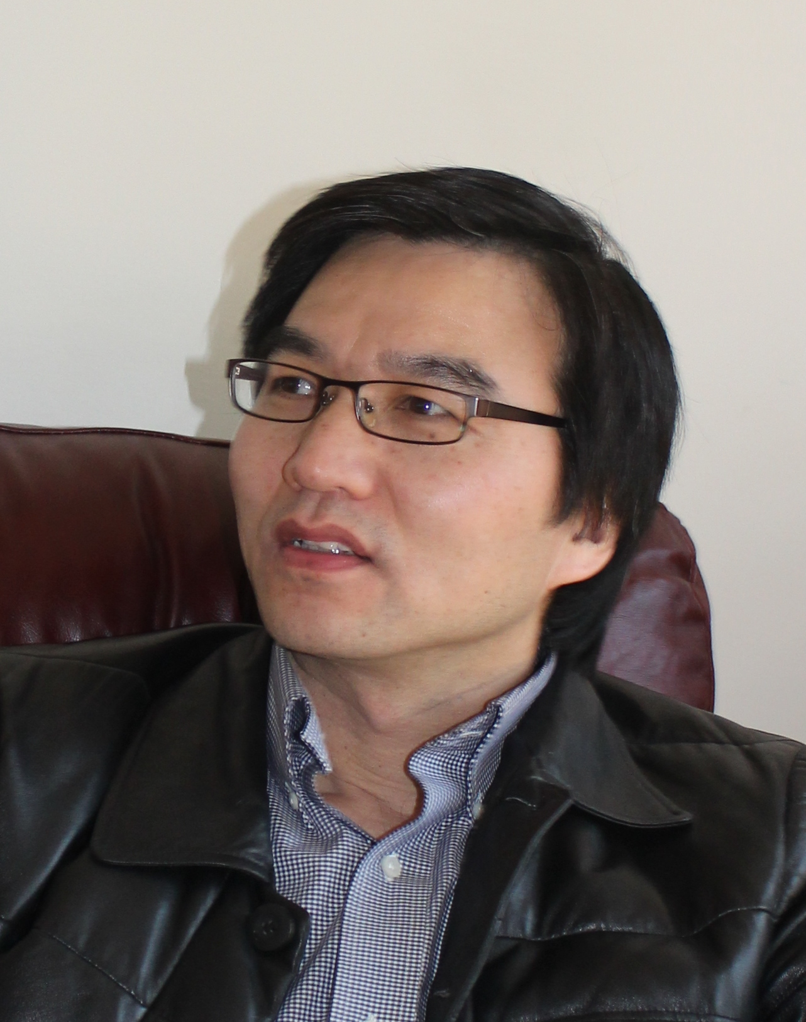
Dinggang Shen is Jeffrey Houpt Distinguished Investigator, and a Professor of Radiology, Biomedical Research Imaging Center (BRIC), Computer Science, and Biomedical Engineering in the University of North Carolina at Chapel Hill (UNC-CH). He is currently directing the Center for Image Analysis and Informatics, the Image Display, Enhancement, and Analysis (IDEA) Lab in the Department of Radiology, and also the medical image analysis core in the BRIC. He was a tenure-track assistant professor in the University of Pennsylvanian (UPenn), and a faculty member in the Johns Hopkins University. Dr. Shen’s research interests include medical image analysis, computer vision, and pattern recognition. He has published more than 800 papers in the international journals and conference proceedings, with H-index 84. He serves as an editorial board member for eight international journals. He has also served in the Board of Directors, The Medical Image Computing and Computer Assisted Intervention (MICCAI) Society, in 2012-2015. He will be General Chair for MICCAI 2019. He is Fellow of IEEE, Fellow of The American Institute for Medical and Biological Engineering (AIMBE), and Fellow of The International Association for Pattern Recognition (IAPR).

