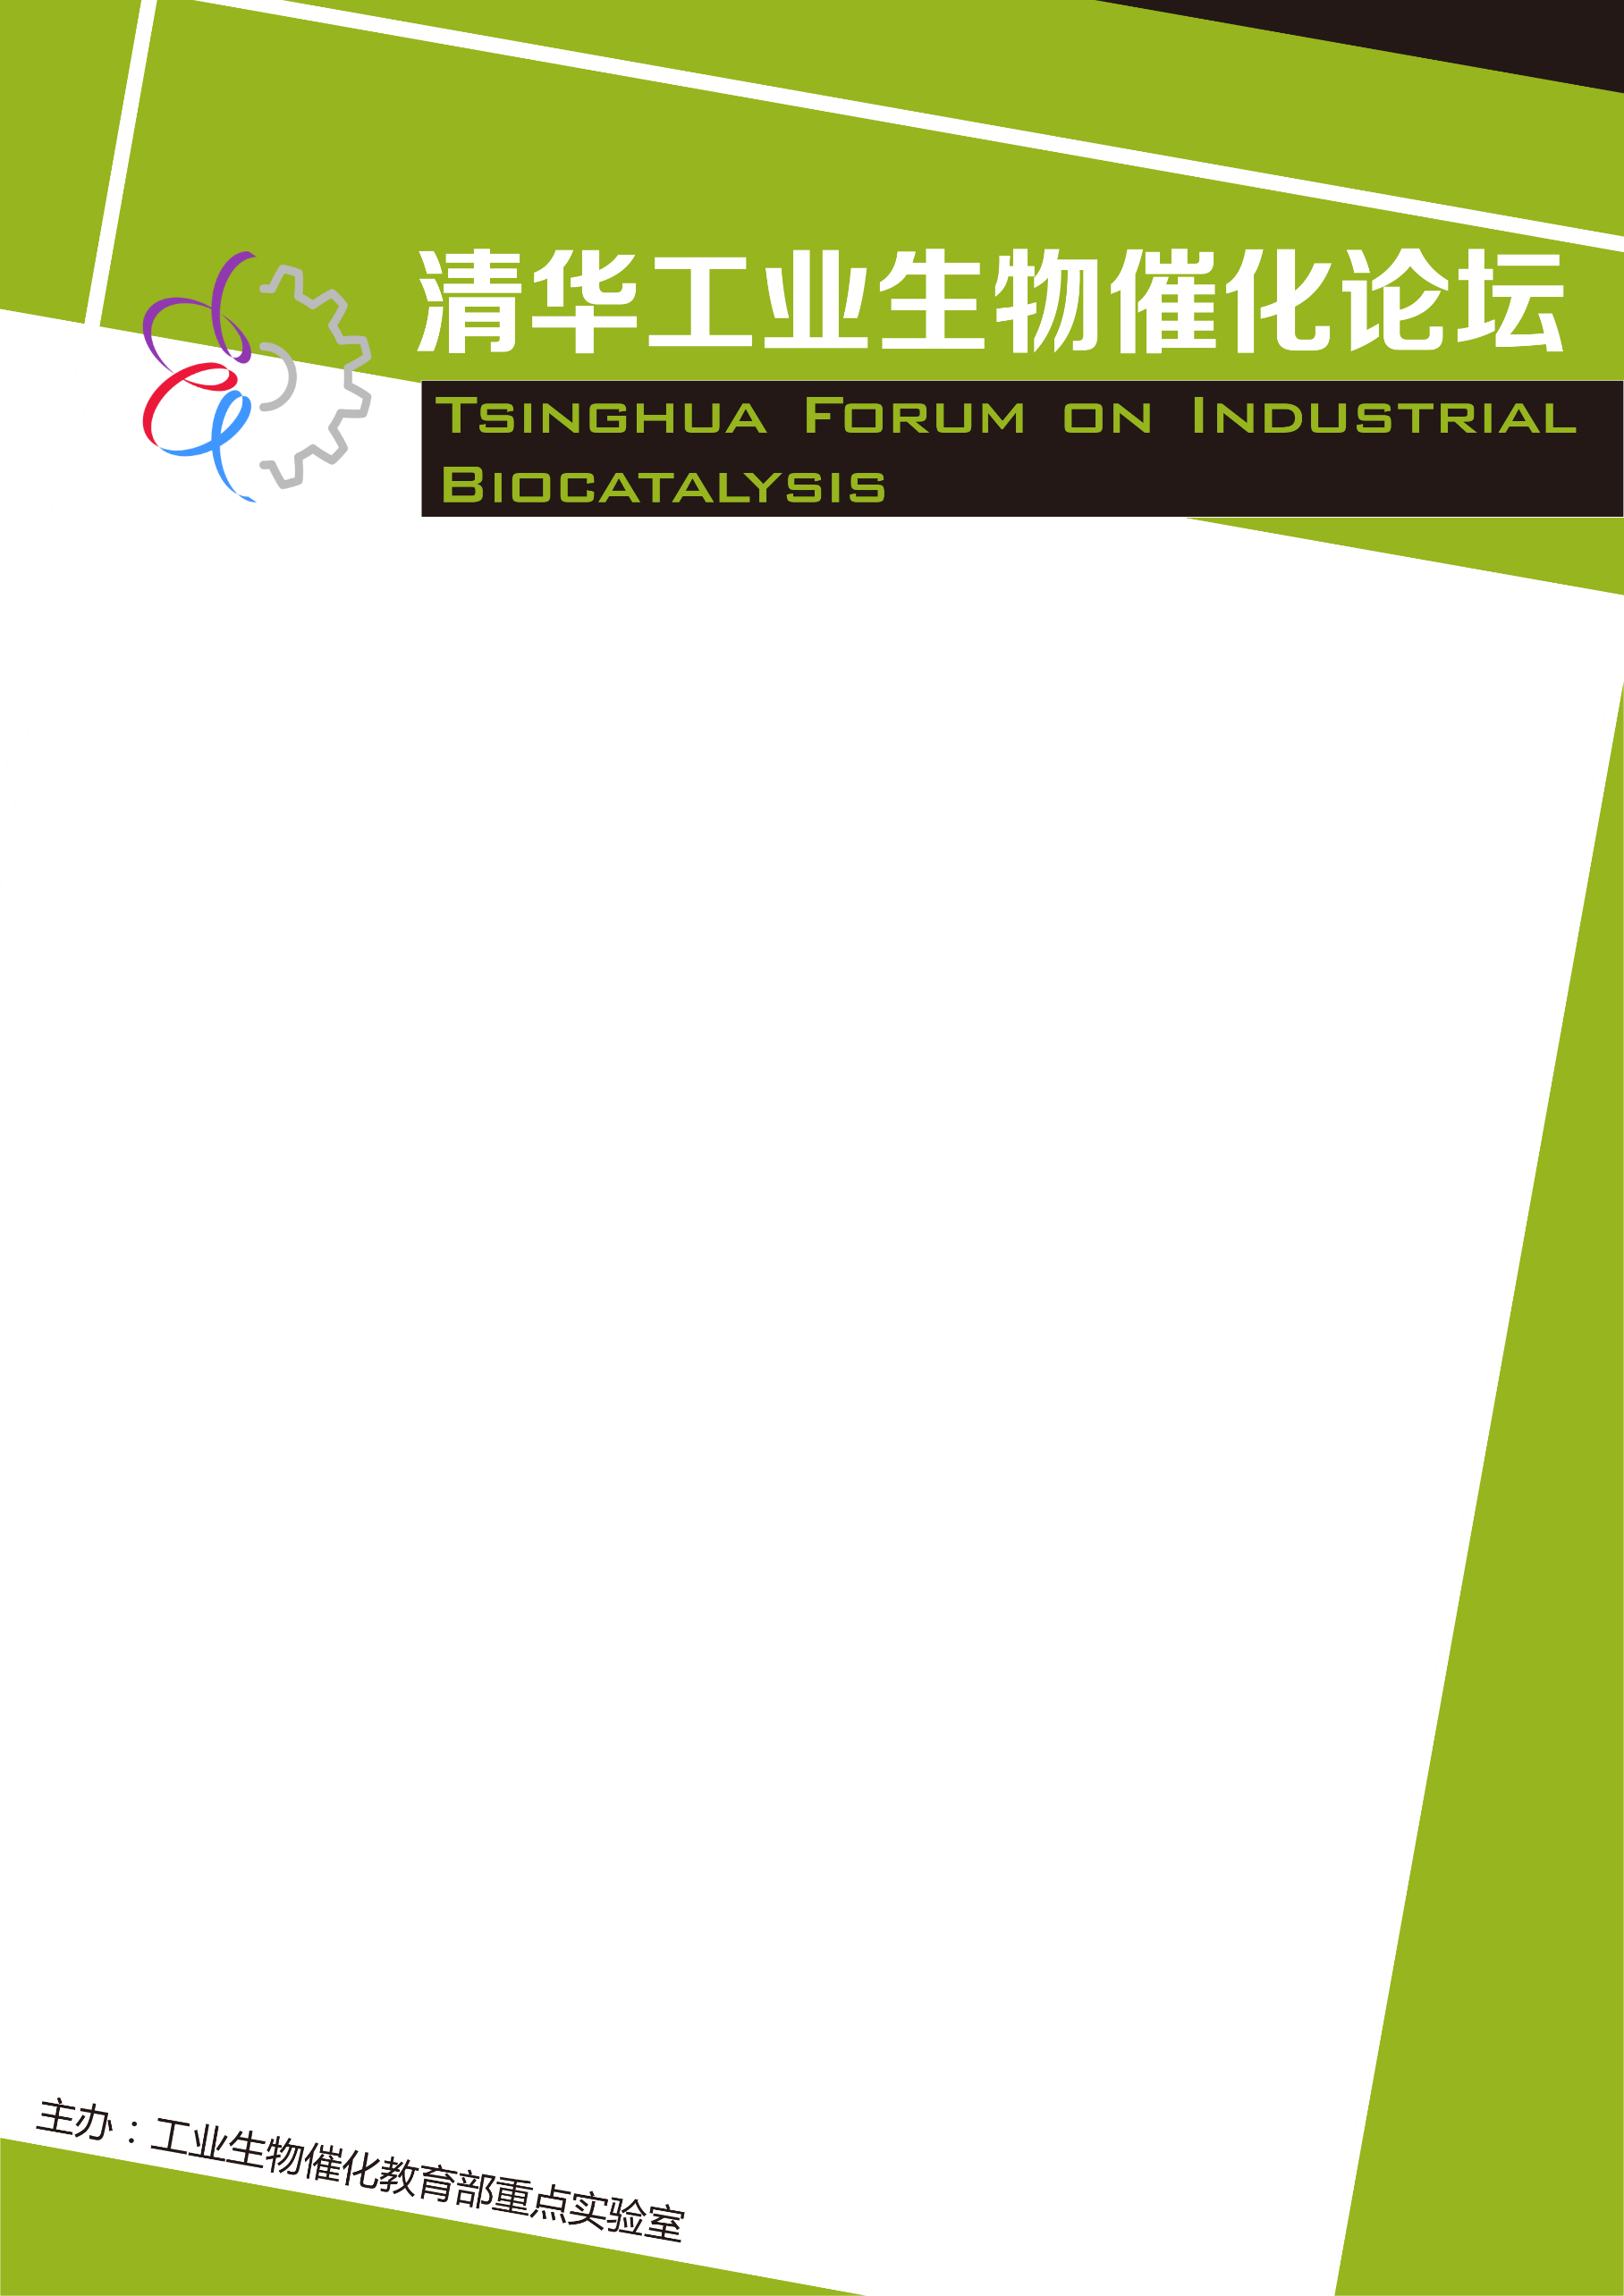
Dr Neil Dixon
Director of Internationalisation, Manchester-Tsinghua Dual PhD Programme Director, Senior Lecturer School of Chemistry, and BBSRC David Phillips Research Fellow at the Manchester Institute of Biotechnology.
Neil Dixon is Senior Lecturer and Director of Internationalisation in the School of Chemistry at The University of Manchester and Programme Director of Dual PhD Programme between Tsinghua University and The University of Manchester. He holds a BBSRC David Phillips Research Fellow, and his research group is based at the Manchester Institute of Biotechnology MIB. His lab’s research goals are to enhance current capacity and incorporate new capability into microbial cell hosts for a variety of biotechnological applications. His group currently comprising of 4 post doctoral scientist, 5 PhD students and 2 Research Technicians is supported from BBSRC, EPSRC, Innovate UK, Wellcome Trust, Brazilian and Indonesian Governments.

Time: 10:00 am-12:00 pm, Sept 18th (Wednesday)
Venue: Room 325, New Biology Building, THU
Host: Dr. CHEN Guo-Qiang

Abstract
Insights from novel mechanistic paradigms in gene expression control, coupled with a greater understanding of host synthetic burden and modern creative bio-design approaches have led to the development of new gene expression systems for bio-production, control and sensing applications. Contemporary bacterial gene expression control tools and systems are emerging that permit fine-tuning of expression, enabling us to maximise specific productivity, whilst minimising deleterious effect on cell viability. Here we will report a variety of approaches taken by our research group to harness and optimize gene expression control tools for biotechnological applications in sensing, control, discovery and production .

Development and application of genetic
regulation tools for biotechnology

