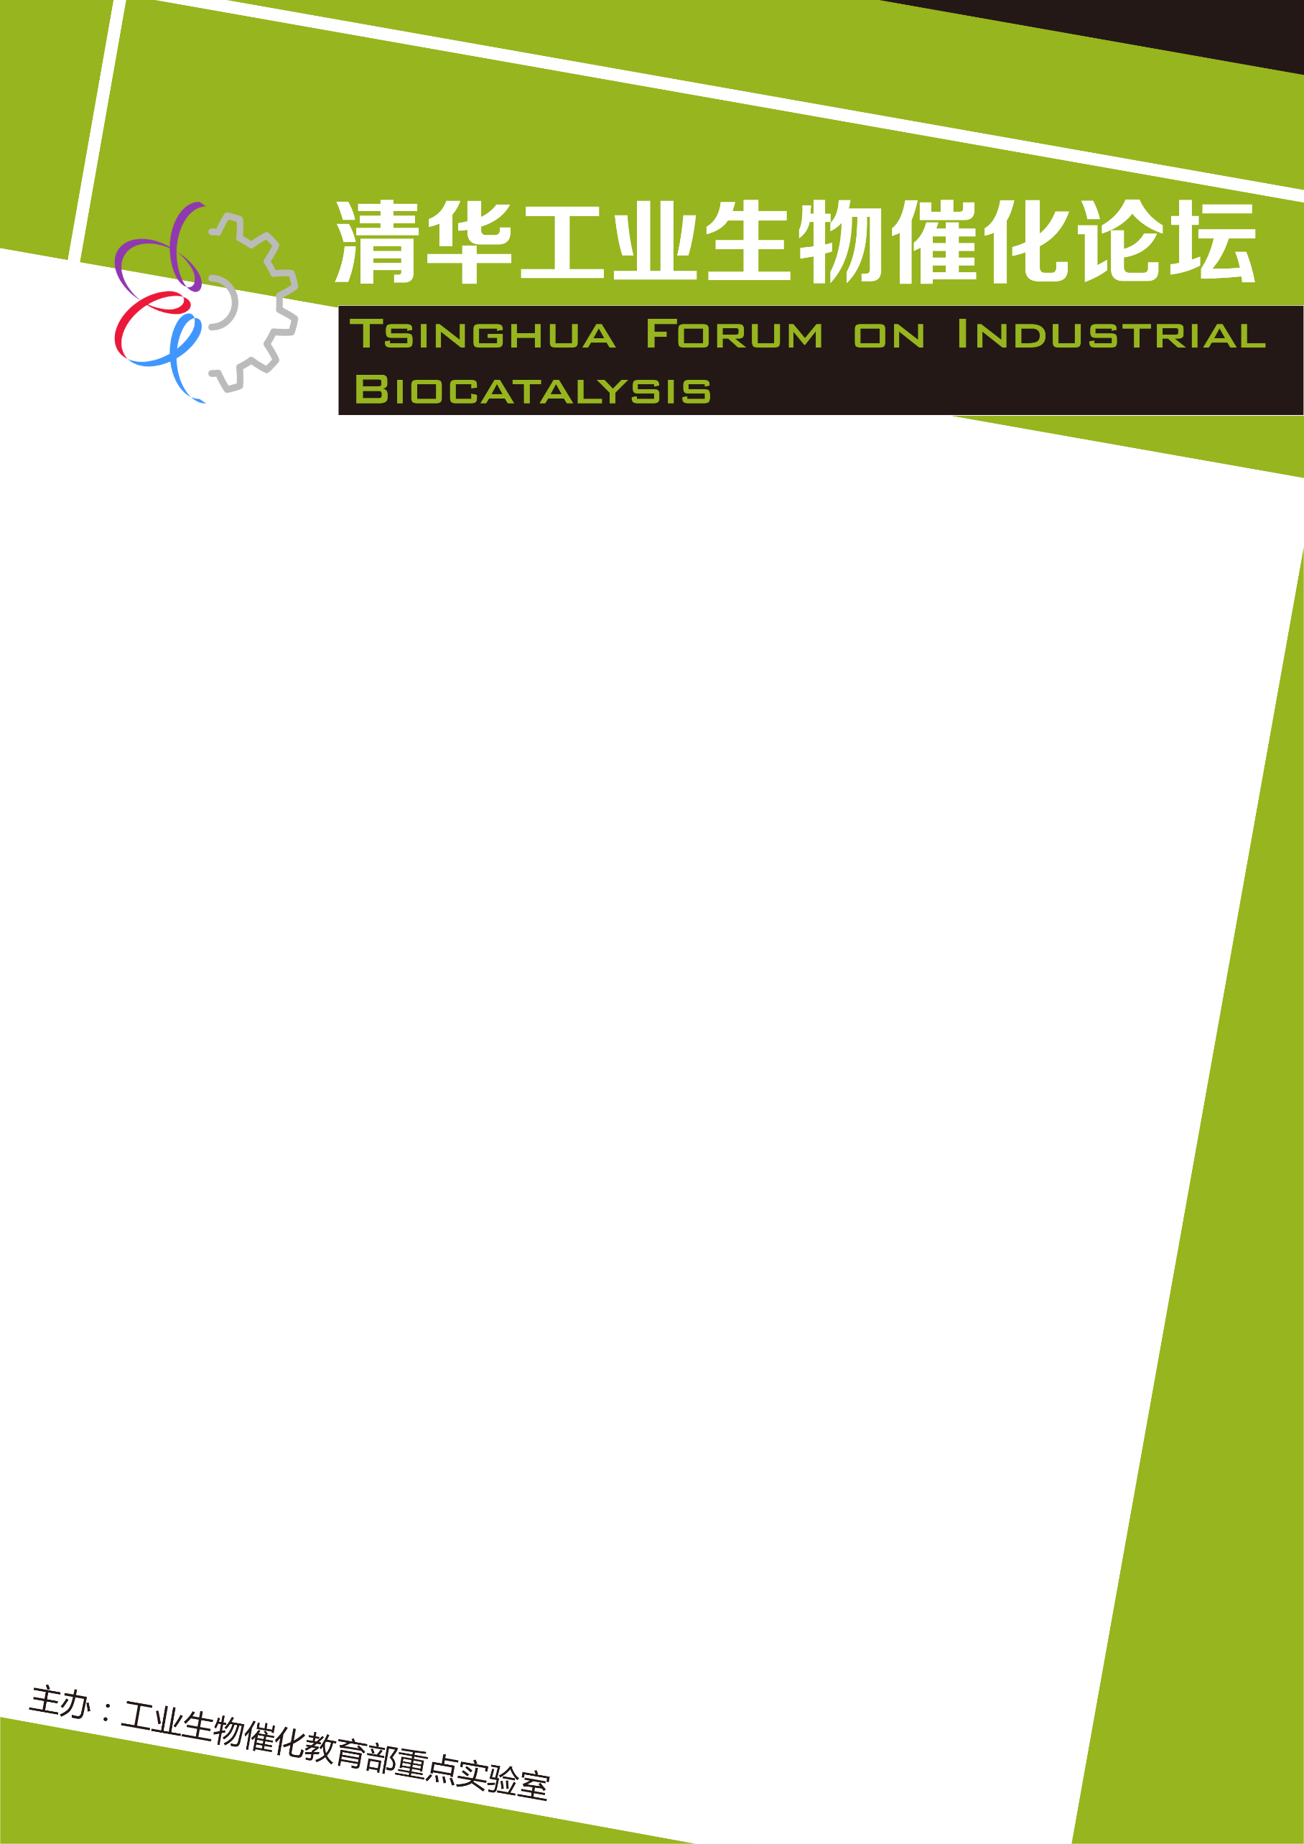
报 告 人：Prof .Paolo Falcaro
Graz University
报告时间：2019年09月24日 下午4：00
报告地点：英士楼101会议室
ERC Consolidator Awardee.
Head of the consortium “Porous Materials@Work” ( TU Graz ) – Austria.
Full Professor at Graz University of Technology ( TU Graz ) – Austria.
Adjunct Professor at The University of Adelaide. Australia
Team Leader of the Adaptive Porous Materials Team at CSIRO – Manufacturing Flagship (Clayton,
Melbourne). Australia
Guest Professor at Osaka Prefecture University – Japan
Research Scientist / ARC DECRA Fellow / Group Leader
CSIRO - Material Science & Engineering division (Clayton, Melbourne). Australia
Post-Doc (OCE Science Leader) CSIRO at Material Science & Engineering division (Clayton,
Melbourne). Australia
Senior Researcher and manager of the Sol-Gel platform at Nanofab (Venice). Italy
PhD in Material Engineering – Padova University (Padova). Italy
Career：
2017

2016

2014-2016

2013
2012-2014

2009-2011

2005-2008
2006

Porous Bio-composites Prepared via Encapsulation of biomacromolecules in MOFs

Main Areas of Research
Investigation of porous materials prepared via self-assembly methods. Porous materials of interest include Metal-Organic Frameworks (MOFs) and Mesoporous Silicates. With the final aim of bringing new porous-based materials towards practical applications (e.g. sensing, biotechnology, environmental remediation and optics) the Falcaro group engineers novel porous composites and designs protocols for the fabrication of porous material-based devices.

