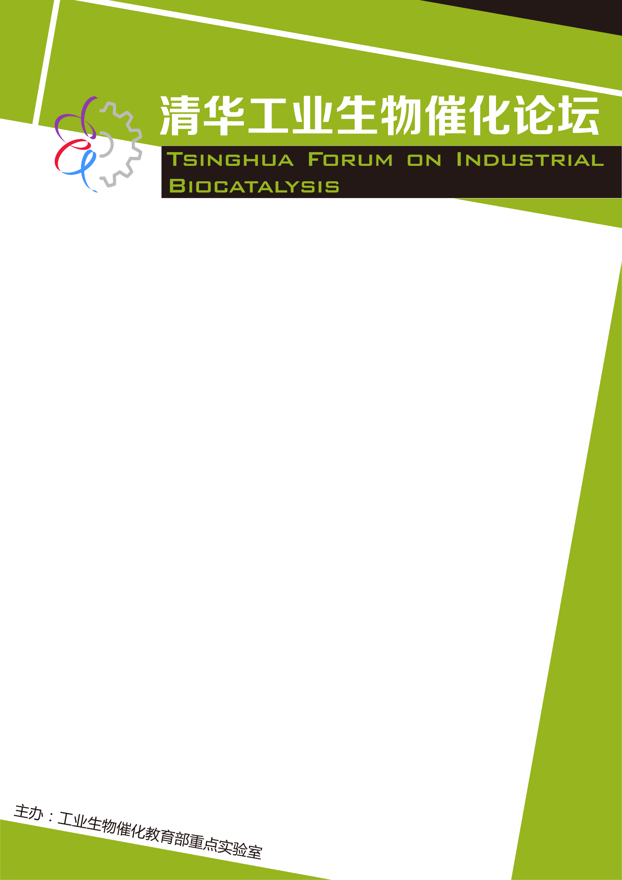
In The Rime of the Ancient Mariner (1798), the great English poet Samuel Taylor Coleridge wrote “Water, water, every where, Nor any drop to drink.”
Indeed, water covers about 70% of the surface of the Earth, and human life depends on potable water. Water is so abundant, its behavior so familiar, its appearance so commonplace, that we are tricked into thinking that there is nothing new to be learned about this substance. We may, however, be in for a surprise...
Unquestionably, water is a weird liquid in which its solid form, ice, floats on liquid water at room temperature. If water were not densest at 4˚C, ice in ponds and rivers would freeze from the bottom up and kill all aquatic inhabitants; if water did not absorb heat so well, water on the Earth would have boiled away long ago; and so forth. Parents often tell their children to wash their hands and regard water as a harmless but excellent solvent. Imagine then our surprise to find that tiny water droplets can be highly reactive and behave remarkably different from that of bulk water. This talk will emphasize the odd world of water microdroplet chemistry, which is threatening to have practical applications.
报 告 人：Richard N. Zare
Stanford University
报告时间：2019年09月25日 下午3:30-5:00
报告地点：英士楼201会议室

Water So Common, So Mysterious


